Tomás, Flávia

Technical:
- What is it?
- How does it work?
- What are the essential mechanisms and processes associated with it?...

Social, Economic and Ethical:
- To whom it it targeted?
- What has been its impact on people’s way of living?...
- Which economic implications can be associated with the chosen service, product or technology?
- Can you identify a business model associated with it?
  - Como é que eles fazem € ? Falar q eles sao um unicornio, ganharam €€ af como startup, tao bue bem avaliados, etc
  - https://blog.pluga.co/uploads/2016/07/o-que-%C3%A9-slack-A.png
- Are there ethical issues related to the chosen service, product or technology?
- Is there a fair usage of the envolved resources (material, informational, economical, etc)?

SLACK - REST - FOLGA (pode entrar isto no framework maybe)

Introduction

In this assignment, it will be analysed the application Slack, which is a business focused communication platform directed at work teams. It is a service that helps us ease and organise work, providing a broad spectrum of tools that can be used and reused to achieve a more concise work process. It was chosen because it is a very appreciated tool in our workplace and it has become essential in terms of simplifying our way of working and communicating with colleagues and team members. We approach the subject by two different angles: Technical (describing the software and its functionalities) and Social/Economical/Ethical (analysing all its implications in people’s lives and economical wise, etc).

What is it?/How does it work?
- O que é Slack? Como funciona Slack? Quem usa?
- Central de Ajuda do Slack

Slack is a space of collaboration that can replace email. It helps teams working together. It has a team-first approach. It’s a place to communicate and get work done, taking advantage of the cons of email.

It works with workspaces, shared spaces that are formed by channels, where team members can communicate and work together. You can have multiple workspaces, each one assigned to an email (same email can go for multiple workspaces).

Inside workspaces there are channels, where team members can send messages and share archives. Channels can be created for teams, projects, or any other thing that is of your interest. They can be public, private, shared and channels that belong to multiple workspaces.

Public channels can be accessed by anyone inside the workspace. In private only invited people are allowed to get in. Shared channels allow two organizations to work on the same channel, each one inside their own workspace. Last, channels that belong to multiple workspaces connect different workspaces inside an organization of Enterprise Grid (Paid plan).

Each channel must have a topic, a description and a nomenclature. Conversations can have sub-conversations, threads, you can reply to a message and it groups the replies, so that the channel keeps organized and with a clean look.

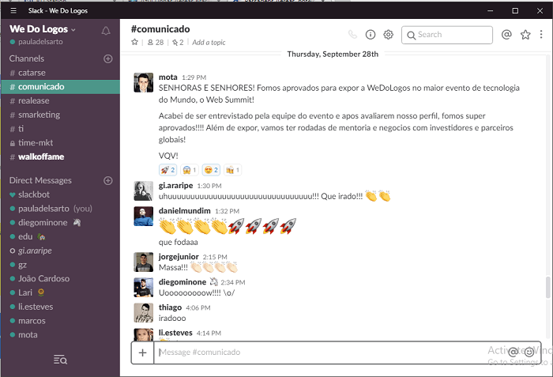

Slack has 4 different plans and resources: free, standard, plus and enterprise grid. Each one offers different things, from unlimited messages, files and apps to calls with multiple participants

Members inside a workspace can have different permissions, there are 2 types of functions: administrative and non-administrative functions.
Administrative functions are: main owner, owner and admin. There is only one main owner, he has the max level of permissions, he is the only one that can delete or transfer the workspace to another person. There can be many owners of the workspace; they have the same permission levels of main owners but cannot exclude or transfer the workspace. Same happens with admins, an workspace can have multiple; they can manage members, channels and other administrative functions.
Non-administrative functions are: member and guest.
Members are persons that participate in a workspace; they can use Slack to communicate and work with their team. Guests participate in the workspace but have limited access; they can only join one channel and interact only with the people that are in that same channel.

Slack have an awesome feature: apps. Apps are software that connects a service or a tool to slack. They centralize and simplify the work. With all the apps on the workspace it’s easier to manage your work. There are a lot of integrated apps: Google Drive, Google Calendar, Polls, Zoom Meetings, GitHub and so on. They all have unique features, Calendar can notify you for events, with Zoom you can start a meeting in seconds, and so on.
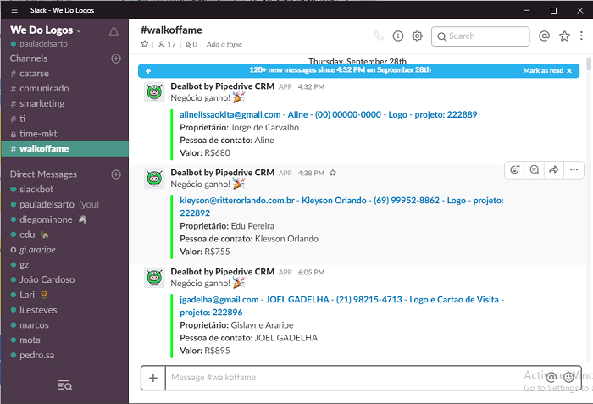

_____________________

Slack brings together people, applications and data.
It replaces email inside a company. Reduces the amount of emails sent.
Inside of a company, there’s enormous flows of critical information

To whom it it targeted?
- Histórias de clientes

Slack it’s targeted to companies, group projects, literally any team that wants to promote the efficient teamwork, economize time working smarter and work in any place place via phone, tablet or PC. They offer solutions to low and enormous groups, from free tier to enterprise grid.

We have multiple examples of companies that integrated slack. We have the example of IBM that implemented Slack throughout the development lifecycle. On a single day, any worker will have to work with other 40 or 50 different people, all on different teams. So they decided to implement slack, dividing each team on channels (#development-team, example) and also implemented help channels. Each channels works as a “kind of audit trail”, all analysis for their post-mortems have a history on slack channels.

Fox, the television channel, with more than 22 thousand employees, uses slack to collaborate on live events, where the team members (producers, designers, casters, and so on) need to work on real time. CTO of Fox said “Before, it took us hours to create, approve and transmit the best moments of a sport event. Now, with slack, it takes minutes, it’s almost on real time”. They used Slack on the Fifa World Cup 2018. The collaborators that were on the local took photos and videos and shared on #worldcup-digital channel. The production team shared that material on other channels so that the others teams could use them. To synchronize the work they had quick meetings with the Zoom integration on Slack.
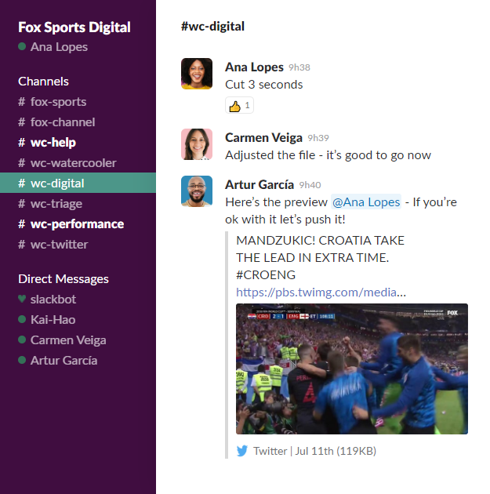
They also implemented multiple bots to control access request of new freelancers to join the team, to show the stats of games highlights, and many more.
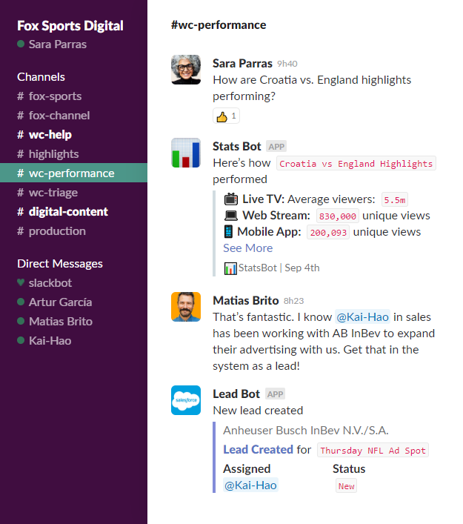

One relatable example is the use of Slack on DETI, Departamento de Eletrónica, Telecomunicações e Informática. We have a common use of Slack; channels divided by associations (GLUA, AETTUA, ... ), course units and topics.
Other examples are Oracle, ETrade, The New York Times, Deliveroo, Vodafone, BBC, Trivago, Shopify, and so on.

What has been its impact on people’s way of living?

As can be seen in other communication apps similar to Slack, it provides several benefits such as saving time, strengthen and facilitate team interactions and promote organized team and user environments.
Since slack provides numerous applications within itself, making it possible for the user to complete tasks in fewer steps, it also makes the communication between team members faster and simpler, eliminating the need of back-and-forth emailing. This application can eliminate the need for the team to use multiple other technologies to organize their works or keep information up-to-date (etc).
Slack can be the perfect fit for large teams where people perform multiple and diverse functionalities due to the pervasiveness of its communication tools.

On the other hand, it seems that Slack’s simplicity and ease-of-use (which was the main reason why it became popular in the first place) may also be a problem. This happens for some reasons: since messaging becomes the default way of communication, it lowers the barrier to initiate communication resulting in an overload of messages and channels, which would not happen by communicating through e-mail. This also lowers remote workers’ need of showing that they’re working because, by exchanging messages, they are automatically presenting what they are doing, which subsequently reduces their productivity. In addition, these types of chat apps are distracting platforms for workers, which was proven to be true by comparing the measures of the productivity of users of RescueTime when Slack was down for a few hours on June 27, 2018 and the week before.

- 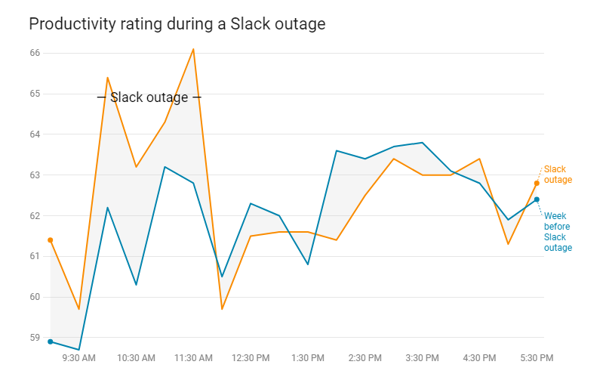

- https://observer.com/2018/10/slack-worse-workplace-productivity/

Which economic implications can be associated with the chosen service, product or technology?
Slack has a free plan, but it has some limitations. The bigger the companie, the bigger are the limitations.
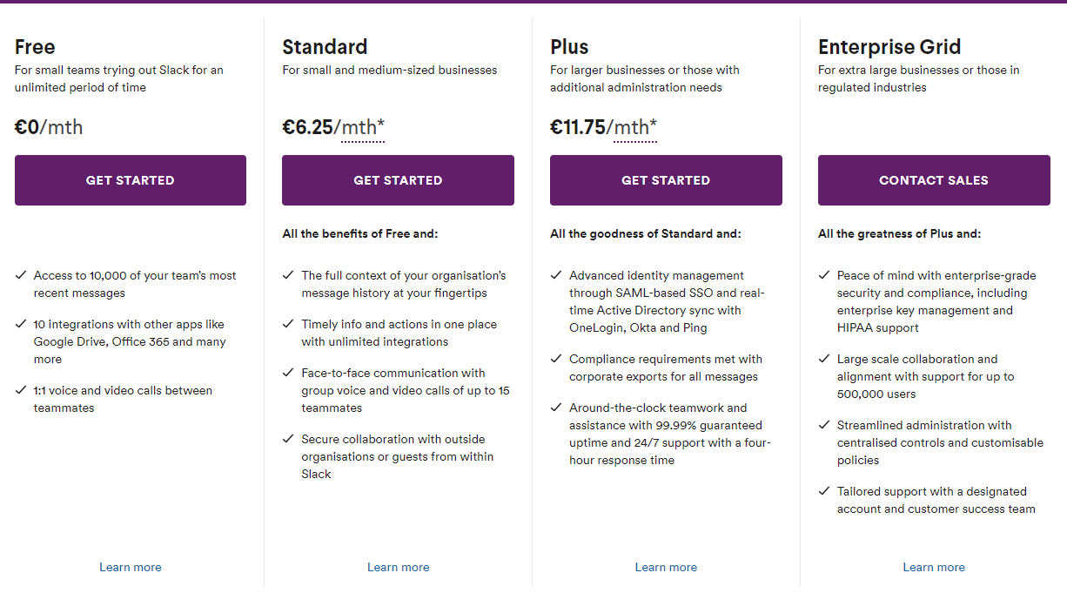

Can you identify a business model associated with it?

The business model associated with Slack would be Freemium Base Membership or Recurring Model. The Freemium is a type of business model that offers users simple and basic services free to try, hoping that the user needs will increase and eventually move into premium membership with more advanced services or additional features.

This model, by giving away a free of charge service, is trying to establish a foundation for future deals with the costumer.
As it can be seen in the website, Slack charges monthly fees of $6.67 per user for the standard subscription, $12.50 for the Plus subscription an it also has launched Enterprise Grid for larger organizations that have tens of thousands of users .
Unlike other softwares such as this one, Slack charges organizations only for active users.

In order to keep progressing with terms of selling its product, the key resources of the company are sales, development teams, marketing and research.
The company, in addition to their web browser and desktop software for Windows, Linux, macOs, provides mobile apps for Android, iOS, etc and it’s also available in Apple Watch.
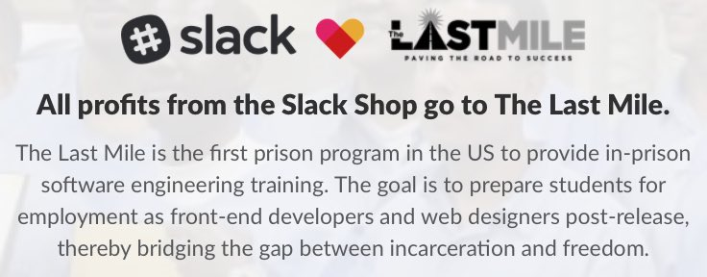
This company is known to give second chance to former inmates, in partnership with The Last Mile, by training them, hiring them and bringing them back into the world and shift misconceptions around this returning citizens.

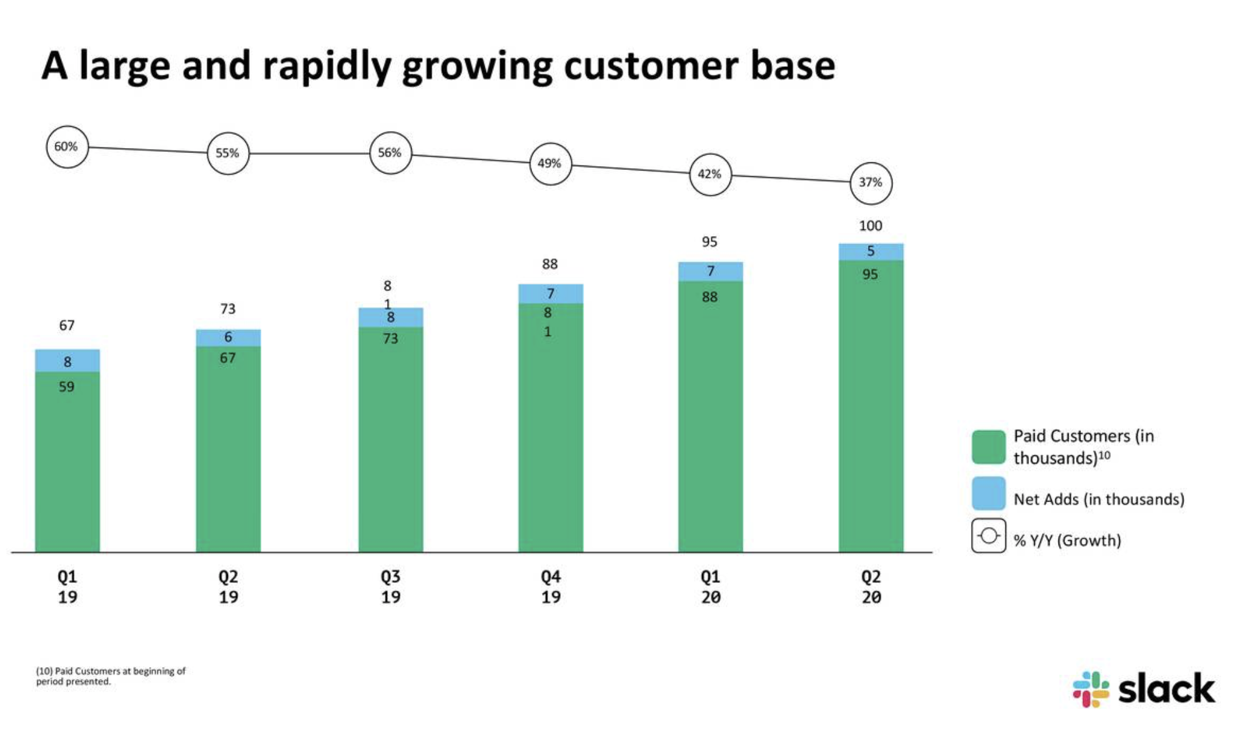

Slack is among the most valued “unicorn”, i.e. a startup with funding worth at least $1 billion. It announced that it has more that 8 million daily active users and more than 70.000 teams that subscribe to paid/premium services.
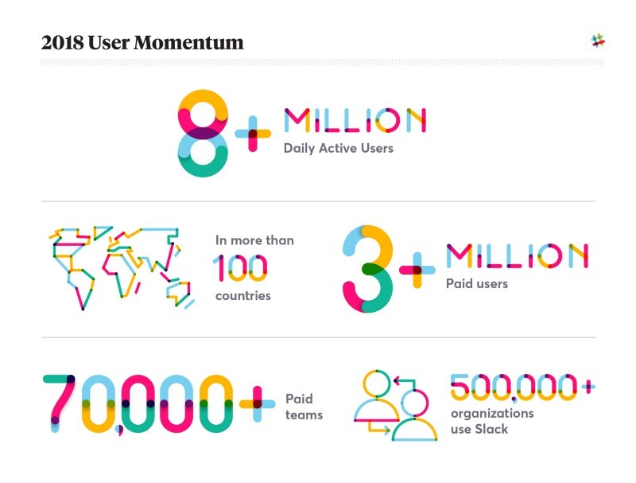
On the year 2017, Slack was recognized as the best startup of the year at an event organized by TechCrunch, The 10th Crunchies Awards.

https://www.cleverism.com/company/slack/
https://www.theatlantic.com/technology/archive/2019/12/from-prison-to-silicon-valley/603406/

Are there ethical issues related to the chosen service, product or technology?
- What are Ethical Issues? - Definition | Meaning | Example
Nope. Slack’s objective is to promote a good moral on companies, to promote teamwork in a fast and easy way. They aim to solve the problems that they identified that were occuring and developed a product to address those problems.

Is there a fair usage of the envolved resources (material, informational, economical, etc)?

There are reports of some security concerns regarding the exchanges of messages between team members on the software, but Slack assures that it provides security practices at many levels such as data encryption, security features for team members & administrators (access logging, data retention, deletion of customer data, return of customer data, team-wide two-factor authentication, single sign-on), availability, disaster recovery, network protection, host management and product security practices.
Slack’s users complained about several issues regarding privacy policies, such as Slack storing their data only on cloud servers, which was an issue for users enrolled in large teams, who experienced connectivity issues, difficulty accessing their messages and other user restrictions. The company also went under fire for changing their privacy policy without warning its users, allowing workplace administrators to gain access to all channels, public and private, not providing any notification to the users on their data being accessed. It has also been deemed as highly addictive, a potentiator to setbacks on productivity and poor management on users private information.

How Secure Is Slack for your Business?

